Eastron LoRaMESH Communication Test

1, Default Parameters of ESP-6：
1.1, Default IP information of ESP-6:
IP address：192.168.1.200;
Subnet mask: 255.255.255.0;
Default gateway：192.168.1.1;
Default RS485 communication parameter : 9600bps, 8 Data bit.
1.2, Default LoRa communication parameter of ESP-6 : SF = 9, Frequency = 868 MHz;

2, Connect ESP-6 to the PC
2.1, If ESP-6 is connected to PC via Ethernet, please set the IP address of PC to be in the same network segment as that of ESP-6.
For example: as shown below, the IP address of PC is consistent with ESP-6(IP: 192.168.1.1), except for the last number.
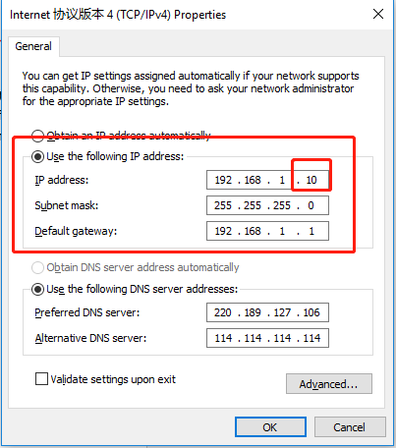
2.2, If ESP-6 is connected to PC via RS485, the parameters of communication software on the computer need to be set to match ESP-6.

3, Default communication parameters of SDM230-LoRa：SF = 9，Frequency = 868MHz；
How to check the communication parameters of the meter:
A, Power on the meter;
B, Long press the button for setting on the meter panel for 3 seconds when the meter shows the password interface;
C, Enter correct passwords by pressing the button (default password =1000), then long press the button for setting 3 seconds to confirm;
D, Short press the button for page turning to find the setting interface of LoRa SF and LoRa Frequency, and then long press the button for setting 3 seconds to check.
Remark：1), 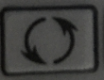 Button for page turning; 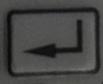 Button for setting.
2), The setting interface of LoRa SF 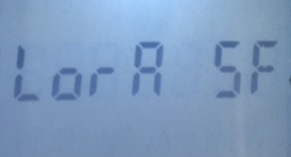 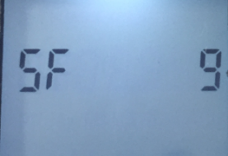
3), The setting interface of LoRa Frequency 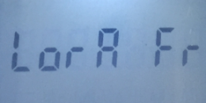 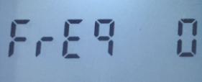; In this setting interface, the value of LoRa Frequency is displayed in index number. Please see the following table for the corresponding LoRa Frequency value of the specific index number:

Index Number | LoRa Frequency
0 | 470.8MHz
1 | 471.1MHz
2 | 471.4MHz
3 | 471.7MHz
4 | 472.0MHz
5 | 474.1MHz
6 | 475.0MHz
7 | 475.3MHz
8 | 475.6MHz
9 | 487.0MHz

4, Check parameters of ESP-6 by setting tool.
A, Open the setting tool after connecting ESP-6 to PC.
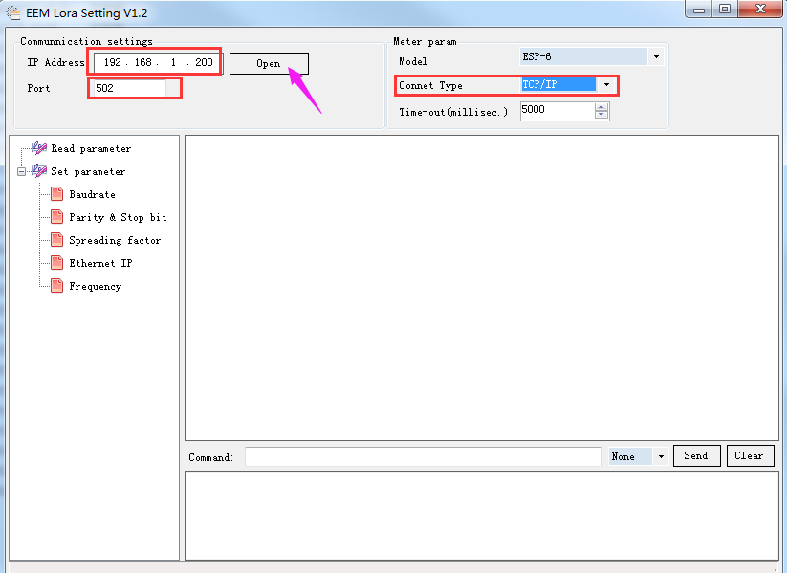

B, Then click read parameters.
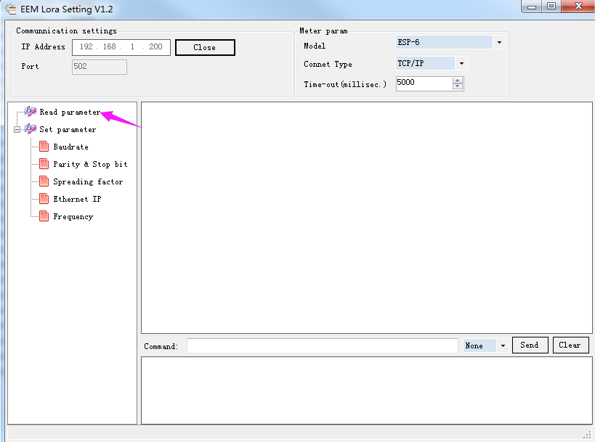

C, Read the parameters as shown below：
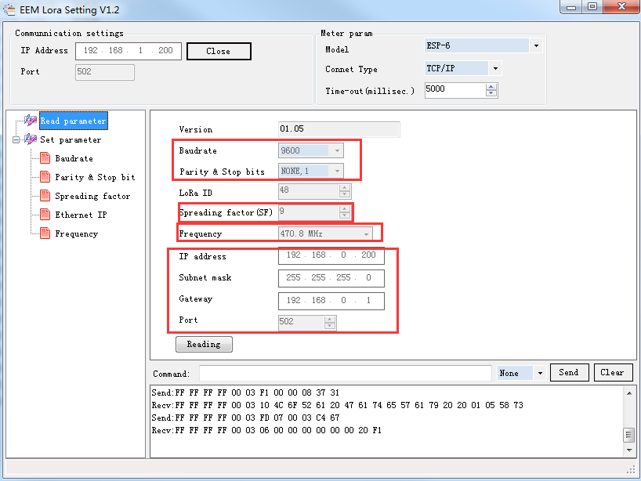

5, Before communication test, please ensure that the communication parameters of ESP-6 and LoRa meter are consistent (the LoRa SF and LoRa Frequency of both should be the same).

6, Definition of ESP-6 status indicator light, as shown in the figure below:
A, Status Indicator light: The indicator light is in a fast flicker state (flicker frequency of 100ms) during the initialization process after ESP-6 is powered on; After successful initialization, the indicator light will be on; If initialization fails, the indicator light changes to a slow flicker state (flicker frequency at 500ms).
B, TCP/RS485 indicator light (local communication indicator light): After ESP-6 receives data from PC via Ethernet or RS485 successfully, the indicator light will be on for 100ms and then off.
C, LoRa indicator light (LoRa communication status indicator light): After ESP-6 receives the data that LoRa meter returns, the indicator light lights for 100ms and then goes off. It indicates that the ESP-6 receives the response. If there is a timeout, the indicator light lights for 1 second, then go off.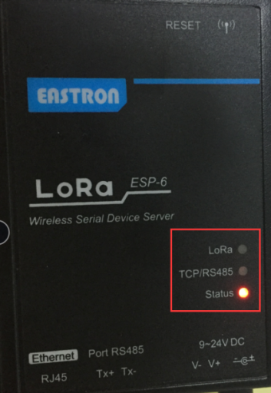

7, Use settings tool for communication test：
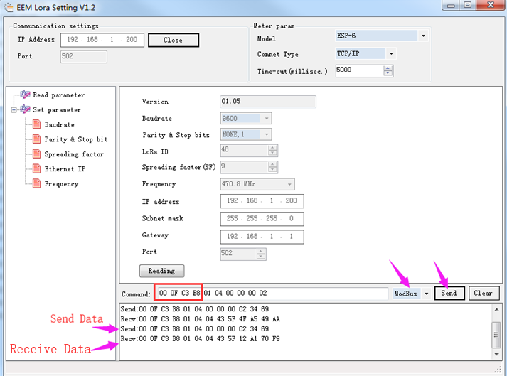
A, Connect ESP-6 to PC, power on LoRa meter, then set it with above parameters.
B, Enter the test command and click “send”.
C, Check if the software receives the data from the meter.
Remark: 1), During the test, please also notice the state of the ESP-6 indicator lights simultaneously to check whether the test is successful or not.
2), The test commands：00 0F C3 B8 01 04 00 00 00 02, The value of the red part is LoRa SN of meter; The black text remains the same.
3), 00 0F C3 B8 is the hexadecimal value of the meter SN (01033144).
Convert the SN of the meter to the above value: use computer calculation, in programmer mode.
